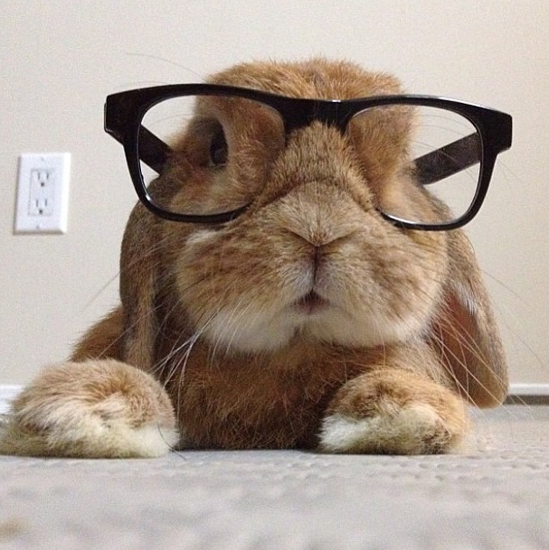
Some bunny thinks you're smart!
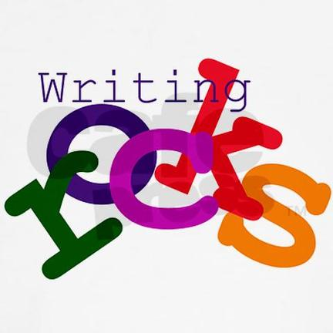
I am so proud of you!



IF YOU WERE A FLOWER, I'D PICK YOU.

YOU ARE
SUPER!


YOU ARE
DOING GREAT!
Munch, munch...
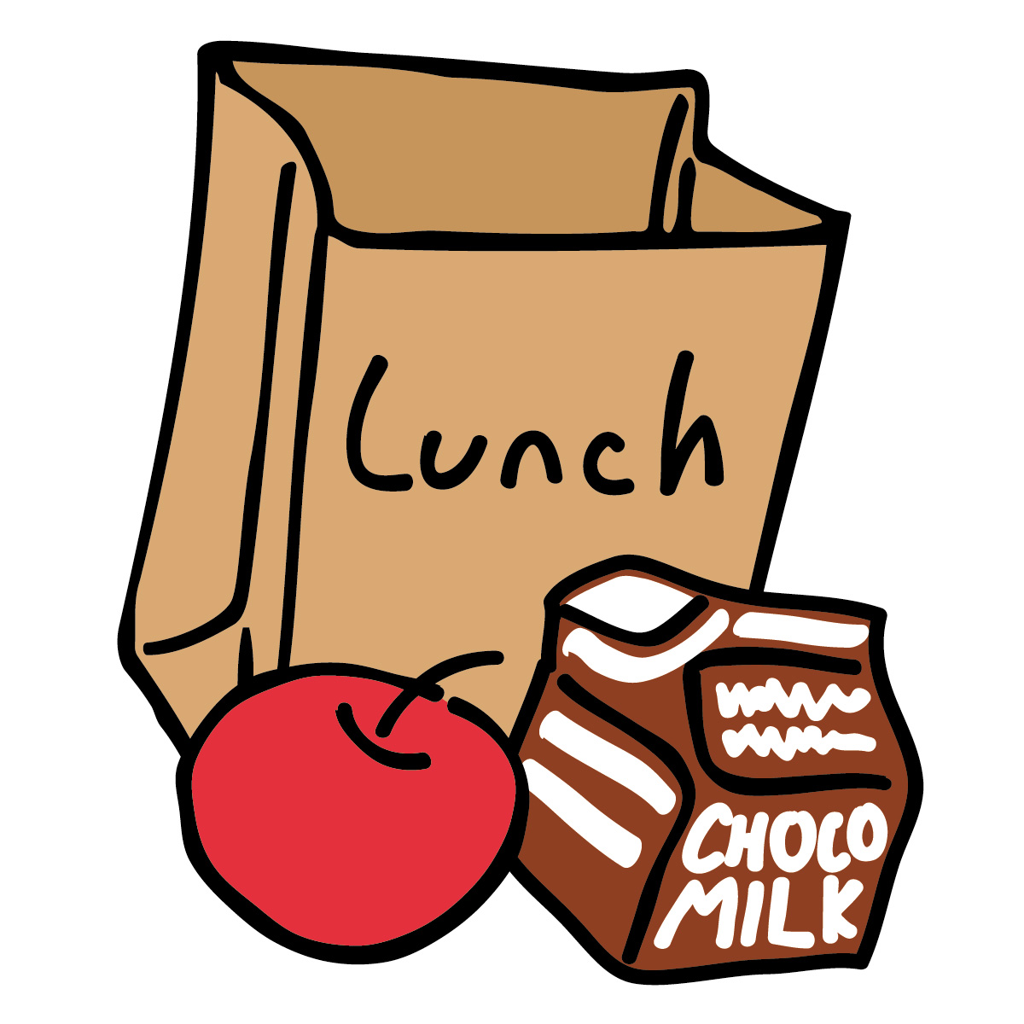
EAT YOUR LUNCH!

